Home contains Header,Two buttons(Direction Service,Elevation Service),footer and a pop-up

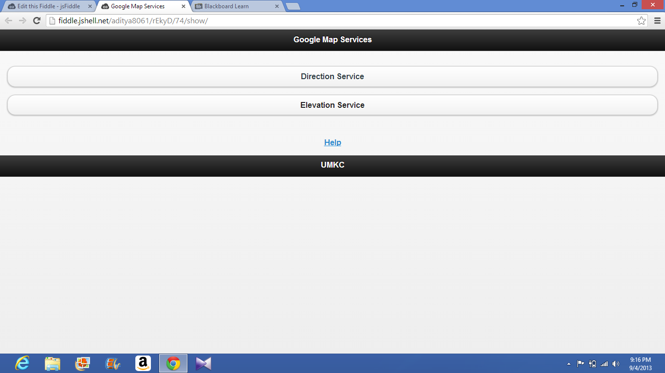

Click on Help Link

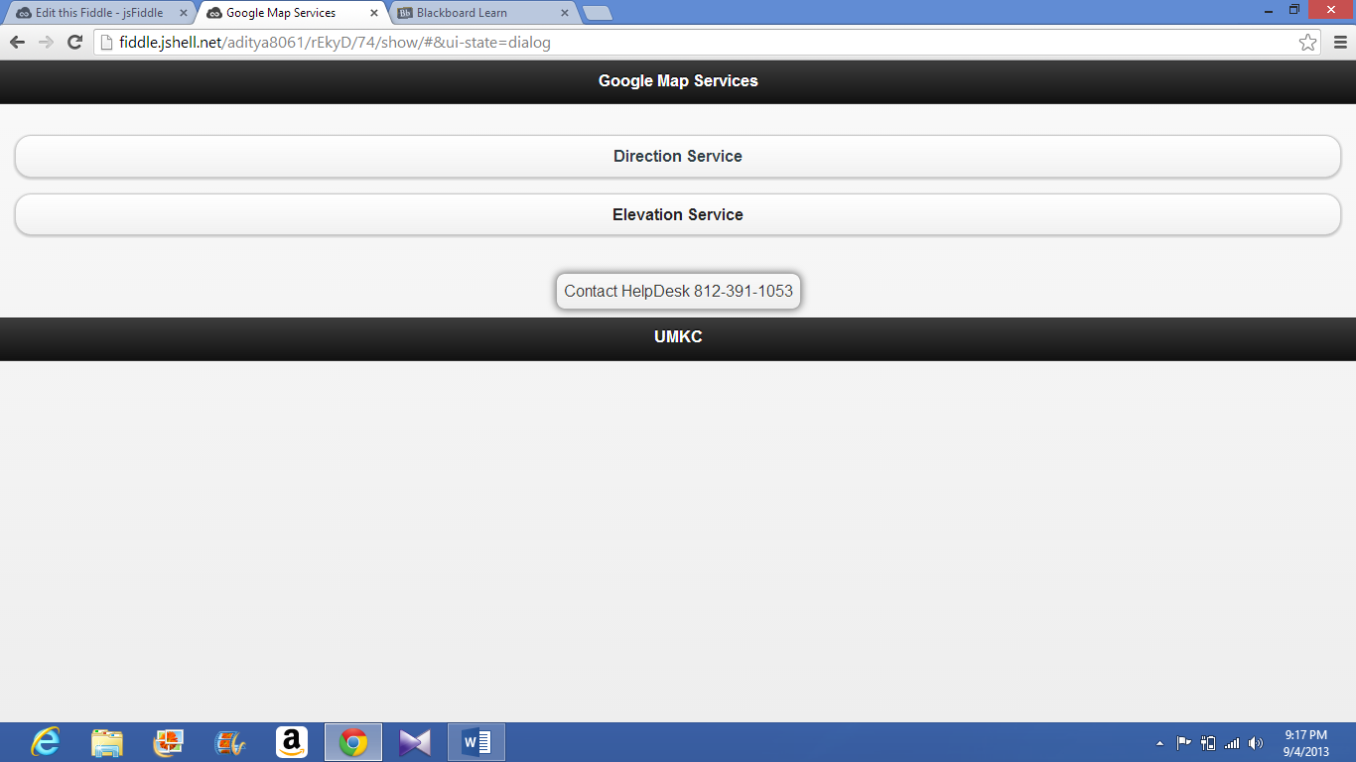

Click on Direction Service button

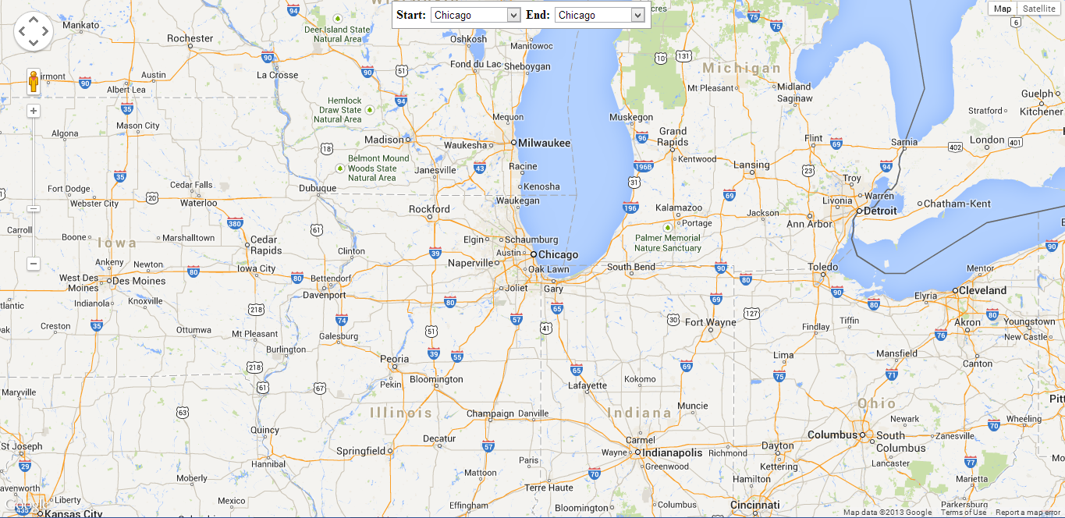

Click on Elevation Service button

